Input space partition

Each block: < 0, = 0, > 0

**Each Choice Coverage**

(-1, -2, -3) (0, 0, 0) (3, 2, 1)

**Pair-Wise Coverage**

(-1, -2, -3) (-1, 0, 0) (-1, 2, 1)

(0, -2, 0) (0, 0, 1) (0, 2, 0)

(3, -2, 1) (3, 0, 1) (3, 2, -3)

Graph coverage

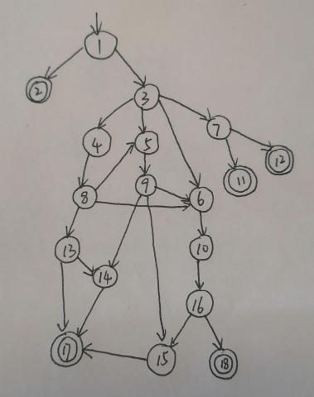

**Node Coverage**

TR={1,2,3,4,5,6,7,8,9,10,11,12,13,14,15,16,17,18}

Test paths = [1,2] [1,3,7,11] [1,3,7,12] [1,3,6,10,16,18] [1,3,4,8,13,14,17] [1,3,4,8,5,9,6,10,16,15,17]

**Edge Coverage**

TR={(1,2),(1,3),(3,4),(3,5),(3,6),(3,7),(4,8),(8,5),(8,6),(8,13),(13,14),(13,17),(5,9),(9,6),(9,14),(9,15),(14,17),(15,17),(6,10),(10,16),(16,15),(16,18),(7,11),(7,12)}

Test Paths = [1,2] [1,3,7,11] [1,3,7,12] [1,3,6,10,16,18] [1,3,4,8,5,9,6,10,16,15,17] [1,3,4,8,13,17] [1,3,4,8,13,14,17] [1,3,5,9,14,17]

**Prime Path Coverage**

Test Paths = [1,2] [1,3,7,11] [1,3,7,12] [1,3,4,8,13,17] [1,3,6,10,16,18] [1,3,4,8,13,14,17] [1,3,5,9,14,17] [1,3,4,8,5,9,6,10,16,15,17]

Logic coverage

Side1 + Side2 <= Side3 || Side2 + Side3 <= Side1 || Side1 + Side3 <= Side2

**Predicate coverage**

Predicate = true

Side1=1, Side2=2,Side3=3

Predicate = false

Side1=3,Side2=4,Side3=5

**Clause coverage**

(Side1 + Side2 <= Side3) = true Side1=1,Side2=2,Side3=3

(Side1 + Side2 <= Side3) = false Side1=3,Side2=6,Side3=8

(Side2 + Side3 <= Side1) = true Side1=3,Side2=7,Side3=7

(Side2 + Side3 <= Side1) = false Side1=1,Side2=2,Side3=3

(Side1 + Side3 <= Side2) = true Side1=2,Side2=6,Side3=3

(Side1 + Side3 <= Side2) = false Side1=2,Side2=4,Side3=3

**Correlated Active Clause Coverage**

|  |  |  |  |
| --- | --- | --- | --- |
| Side1 + Side2 <= Side3 | Side2 + Side3 <= Side1 | Side1 + Side3 <= Side2 | result |
| T | T | T | T |
| T | T | F | T |
| T | F | T | T |
| T | F | F | T |
| F | T | F | T |
| F | F | T | T |
| F | F | F | F |

**Mutation Testing**

**TritypMutantOne**

(3,3,6) (4,4,9)

**TritypMutantTwo**

(1,1,2) (2,2,4)